#include <iostream>
#include <string>
using namespace std;

struct Service
{
string category;
string name;
string area;
string phone;
float distance;
};

void showMenu()
{
cout << "\n========== Nearby Government Services Finder ==========\n";
cout << "1. Hospitals\n";
cout << "2. Police Stations\n";
cout << "3. Fire Stations\n";
cout << "4. Post Offices\n";
cout << "5. Municipal Offices\n";
cout << "6. Government Schools\n";
cout << "7. RTO Offices\n";
cout << "8. Show All Services\n";
cout << "9. Exit\n";
cout << "Enter your choice: ";
}

void displayService(Service s, int index)
{
cout << "\nService " << index + 1 << endl;
cout << "Name : " << s.name << endl;
cout << "Area : " << s.area << endl;
cout << "Phone : " << s.phone << endl;
cout << "Distance : " << s.distance << " km" << endl;
}

void searchByCategory(Service services[], int size, string categoryName)
{
bool found = false;
int count = 0;

cout << "\n--- " << categoryName << " Services in Kakinada ---\n";

for (int i = 0; i < size; i++)
{
if (services[i].category == categoryName)
{
displayService(services[i], count);
count++;
found = true;
}
}

if (!found)
{
cout << "No services found in this category.\n";
}
}

void showAllServices(Service services[], int size)
{
cout << "\n--- All Government Services in Kakinada ---\n";

for (int i = 0; i < size; i++)
{
displayService(services[i], i);
}
}

int main()
{
Service services[14] = {
{"Hospital", "Government General Hospital", "Kakinada", "0884-2301111", 2.3},
{"Hospital", "Area Hospital", "Sarpavaram", "0884-2302222", 4.1},

{"Police", "One Town Police Station", "Kakinada Town", "0884-2303333", 1.5},
{"Police", "Two Town Police Station", "Jagannaickpur", "0884-2304444", 3.0},

{"Fire", "Kakinada Fire Station", "Main Road", "0884-2305555", 2.8},
{"Fire", "Industrial Fire Service", "APIIC Area", "0884-2306666", 5.4},

{"Post", "Head Post Office", "Kakinada Main", "0884-2307777", 1.9},
{"Post", "Sarpavaram Post Office", "Sarpavaram", "0884-2308888", 4.5},

{"Municipal", "Kakinada Municipal Corporation", "Collector Office Road", "0884-2309999", 3.2},
{"Municipal", "Ward Office", "Ramanayyapeta", "0884-2310000", 4.8},

{"School", "Government High School", "Ramanayyapeta", "0884-2311111", 3.6},
{"School", "ZP High School", "Sarpavaram", "0884-2312222", 5.0},

{"RTO", "RTO Office Kakinada", "Vakalapudi", "0884-2313333", 6.2},
{"RTO", "Transport Office", "Madhavapatnam", "0884-2314444", 7.1}
};

int choice;
int size = 14;

do
{
showMenu();
cin >> choice;

switch (choice)
{
case 1:
searchByCategory(services, size, "Hospital");
break;

case 2:
searchByCategory(services, size, "Police");
break;

case 3:
searchByCategory(services, size, "Fire");
break;

case 4:
searchByCategory(services, size, "Post");
break;

case 5:
searchByCategory(services, size, "Municipal");
break;

case 6:
searchByCategory(services, size, "School");
break;

case 7:
searchByCategory(services, size, "RTO");
break;

case 8:
showAllServices(services, size);
break;

case 9:
cout << "\nThank you for using Nearby Government Services Finder!\n";
break;

default:
cout << "\nInvalid choice. Please try again.\n";
}

} while (choice != 9);

return 0;
}
OUTPUT
STEP1:
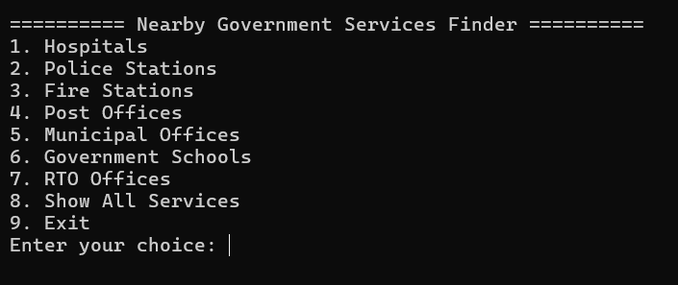

STEP2:-
